CHAPTER 1

INTRODUCTION

1.1 Overview of Internship
Internship is an essential part of academic learning that provides students with practical exposure to real-world working environments. It helps bridge the gap between theoretical knowledge and practical implementation. During the internship period, students get an opportunity to understand industry practices, develop technical skills, and gain hands-on experience in their respective fields.
This internship was carried out at Mitu Skillologies, a company focused on advanced technologies such as Artificial Intelligence (AI) and Machine Learning (ML). The organization provides training and project-based learning opportunities in modern technological domains, helping students build industry-relevant skills.
The main purpose of this internship was to understand the practical applications of AI and Machine Learning, and how these technologies are used to solve real-world problems. The internship also aimed to enhance programming knowledge, analytical thinking, and problem-solving abilities.

1.2 Purpose of the Internship
The primary purpose of this internship was to gain practical knowledge in the field of Artificial Intelligence and Machine Learning. While academic courses provide theoretical understanding, this internship helped in applying that knowledge to real-time scenarios.
The key objectives of the internship include:
- To understand the basic concepts of AI and Machine Learning
- To learn how to work with datasets and perform data analysis
- To implement machine learning algorithms using programming languages such as Python
- To gain experience in working on real-world projects
- To improve problem-solving and logical thinking skills
- To understand the workflow of IT companies and project development lifecycle
Through this internship, the focus was not only on technical learning but also on improving communication, teamwork, and time management skills.

1.3 Relevance to Diploma Course
This internship is highly relevant to the diploma course as it provides practical exposure to subjects studied during the academic curriculum. Topics such as programming, data structures, and basic concepts of computer science are directly applied in AI and Machine Learning projects.
Artificial Intelligence and Machine Learning are emerging fields that are widely used in industries such as healthcare, finance, education, and automation. By working on these technologies, the internship helped in strengthening the understanding of key concepts like:
- Data preprocessing
- Model training and testing
- Algorithm implementation
- Data visualization
- Prediction and analysis
This practical experience complements classroom learning and prepares students for future career opportunities in the IT industry. It also helps in understanding how theoretical concepts are applied in real-life applications.

1.4 About the Organization

Mitu Skillologies is a technology-based organization that focuses on skill development and training in advanced domains such as Artificial Intelligence, Machine Learning, Data Science, and Software Development. The company aims to provide quality education and practical exposure to students through internships and training programs.
The organization provides a structured learning environment where students can work on live projects, understand industry standards, and gain experience in modern tools and technologies. The guidance provided by mentors and trainers helps students in building strong technical foundations.

1.5 Expected Learning Outcomes
At the beginning of the internship, several learning outcomes were expected. These outcomes helped in setting clear goals and tracking progress throughout the internship period.

The expected learning outcomes include:
- Understanding the fundamentals of Artificial Intelligence and Machine Learning
- Gaining hands-on experience in Python programming
- Learning to use libraries such as NumPy, Pandas, Matplotlib, and Scikit-learn
- Developing the ability to analyze and interpret data
- Building and evaluating machine learning models
- Improving problem-solving and analytical thinking skills
- Enhancing communication and teamwork abilities
By the end of the internship, the aim was to gain confidence in working with AI/ML technologies and to be able to develop basic machine learning projects independently.

1.6 Scope of the Internship
The scope of this internship includes learning and implementing various concepts related to Artificial Intelligence and Machine Learning. It involves working with datasets, performing data analysis, and applying different algorithms to generate meaningful insights.
The internship also covers:
- Understanding real-world problem statements
- Designing and implementing solutions using ML techniques
- Evaluating model performance
- Documenting the work in a structured manner
This experience is valuable for future academic projects as well as professional career growth in the field of technology.

CHAPTER 2

COMPANY PROFILE

2.1 Name and Location of the Organization
The internship was carried out at MITU Skillologies, a well-known training and development organization specializing in modern technologies such as Artificial Intelligence and Data Science.
The company is headquartered in Pimpri-Chinchwad, Pune, Maharashtra, India. Its primary office is located at:
Second Floor, Ratnatara Complex,
Kranti Chowk, Navi Sangvi,
Pimpri-Chinchwad, Maharashtra – 411027
In addition to its Pune office, the organization also has a presence in Nashik, Maharashtra.

2.2 Nature of Business / Services
MITU Skillologies operates in the field of software development and education technology (EdTech). The company mainly focuses on providing training, workshops, and internship programs in advanced IT domains.
The key services offered by the organization include:
- Artificial Intelligence (AI) training
- Machine Learning (ML) programs
- Data Science and Data Analytics courses
- Python and Java programming training
- Workshops on emerging technologies like Deep Learning, IoT, and Generative AI
- Faculty Development Programs (FDPs)
- Internship and project-based learning programs
The company aims to empower students and professionals by providing industry-relevant skills through practical and hands-on learning approaches. It focuses on real-world problem solving using data-driven technologies.

2.3 Organizational Structure
MITU Skillologies follows a structured organizational hierarchy to ensure smooth functioning and effective management of training and development activities.
The major roles in the organization include:
- Founder and Managing Director – Responsible for overall leadership and strategic planning
- Chief Accounting Officer – Handles financial operations and budgeting
- HR Manager – Manages recruitment, employee relations, and administration
- Technical Trainers and Resource Persons – Provide training in AI, ML, and other technologies
- Software Developers and Engineers – Work on technical projects and support training activities
The organization has a team of experienced professionals including data scientists, software developers, trainers, and industry experts who contribute to delivering quality education and training.

2.4 Main Departments and Their Functions
The company is divided into several departments, each responsible for specific functions:

1. Training and Development Department
- Conducts courses and workshops in AI, ML, and Data Science
- Designs curriculum and training materials
- Provides hands-on practical sessions

2. Research and Development (R&D) Department
- Works on innovative projects in AI and Machine Learning
- Develops new technologies and solutions
- Supports students in project development

3. Technical Department
- Handles programming, software development, and tools
- Assists in implementation of real-world projects
- Provides technical support to trainees

4. Human Resource (HR) Department
- Manages recruitment and internship processes
- Maintains employee records
- Coordinates training schedules and activities

5. Marketing and Outreach Department
- Promotes training programs and workshops
- Manages social media and communication
- Collaborates with colleges and institutions
Each department plays an important role in ensuring that students receive quality training and practical exposure.

2.5 Internship Department Details
The internship program at MITU Skillologies is specifically designed for students pursuing diploma and engineering courses in Computer Engineering, IT, AI-ML, and related fields.
Key details of the internship include:
- Duration: Approximately 6 months
- Domain: Artificial Intelligence and Data Science
- Training provided by experienced data scientists and industry experts
- Focus on hands-on learning and real-world projects
- Opportunity to work on live company projects after training
- Internship completion certificate provided
The internship program focuses on enhancing technical skills, improving problem-solving abilities, and preparing students for industry-level challenges. It bridges the gap between academic learning and practical implementation.

CHAPTER 3

TECHNICAL CONCEPTS AND LEARNING

Week 1

3.1 Introduction to Python
Python is a high-level, interpreted programming language widely used in fields such as Artificial Intelligence, Machine Learning, Data Science, and Web Development. It is known for its simple and readable syntax, making it suitable for beginners as well as professionals.
Python supports multiple programming paradigms including procedural, object-oriented, and functional programming. During the internship, Python was the primary language used for implementing various concepts and projects.

3.2 Variables and Data Types
Variables are used to store data values in memory. Python does not require explicit declaration of variable types, as it automatically detects the type based on the assigned value.

Types of Data:
- Integer (int): Whole numbers
- Float (float): Decimal numbers
- String (str): Sequence of characters
- Boolean (bool): True or False values
Syntax Example:
a = 10
b = 3.5
name = "Vaishnavi"
is_active = True

3.3 Operators
Operators are symbols used to perform operations on variables and values.

Types of Operators:
- Arithmetic Operators: +, -, *, /, %
- Comparison Operators: ==, !=, >, <, >=, <=
- Logical Operators: and, or, not
- Assignment Operator : =, +=, -=, *=, /=
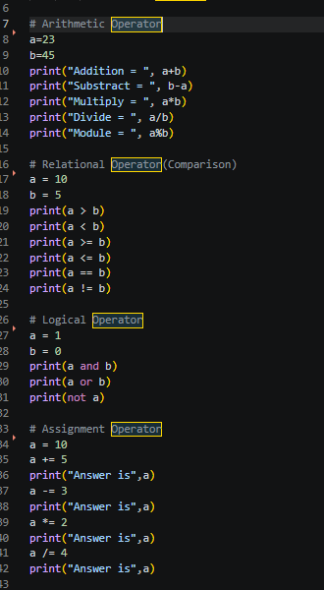
Week 2

3.4 Conditional Statements
Conditional statements are used for decision-making. They allow the program to execute different blocks of code based on certain conditions.
Types:
  - if statement
  - if- else statement
  - if-elif-else ladder
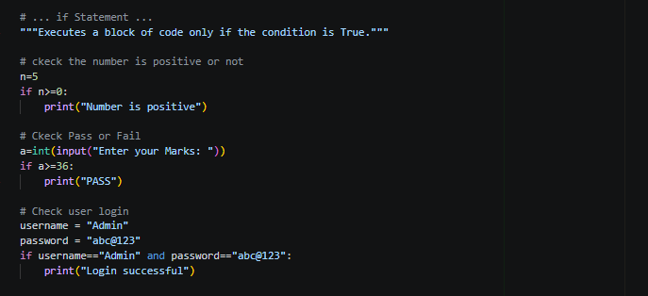
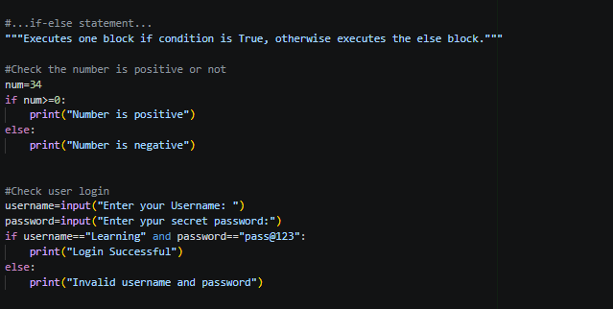
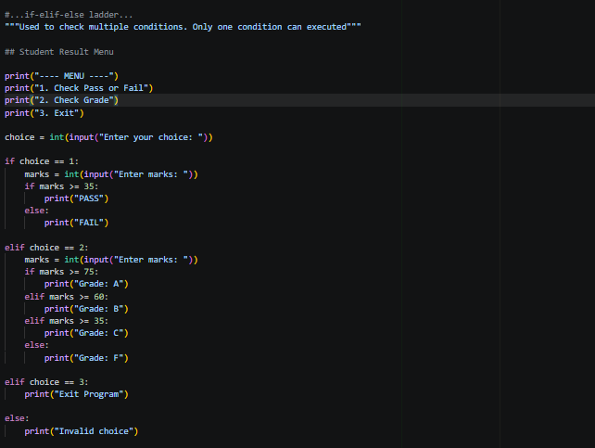

3.5 Looping Statements

Loops are used to execute a block of code repeatedly until a condition is satisfied.

Types :

For Loop

While Loop

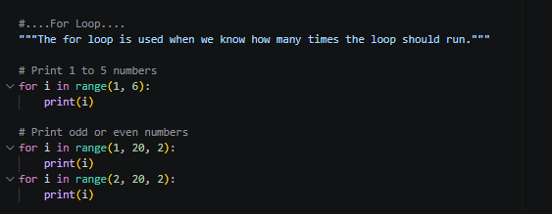
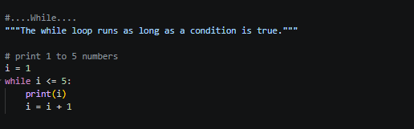

Week 3

3.6 Functions
Functions are reusable blocks of code that perform a specific task. They improve code reusability and reduce redundancy.
Types:
  - Built in function
  - User defined function
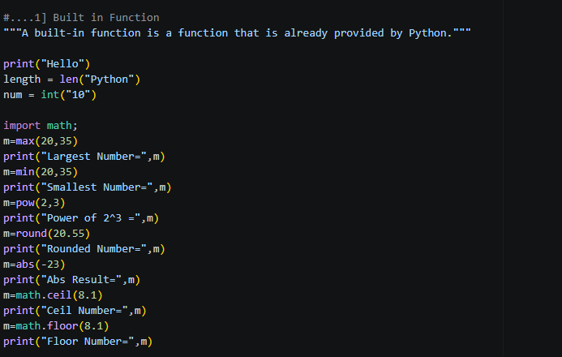
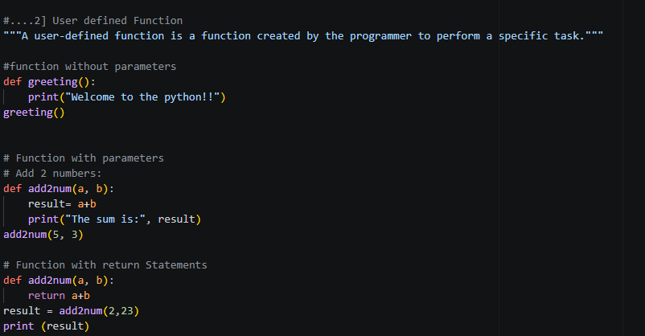

3.6 Data Structures
Data structures are used to store and organize data efficiently.

Types:

1. List: Ordered and mutable collection.

2. Tuple: Ordered but immutable collection.
3. Dictionary: Stores data in key-value pairs.
4. Set: Unordered collection of unique elements.

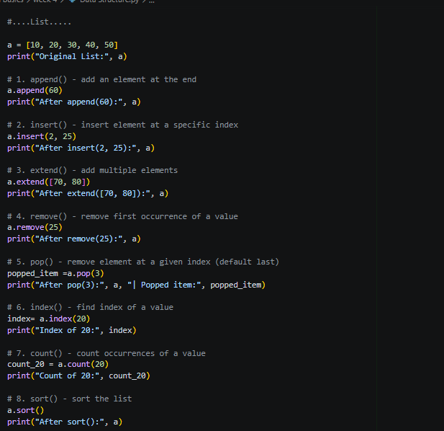
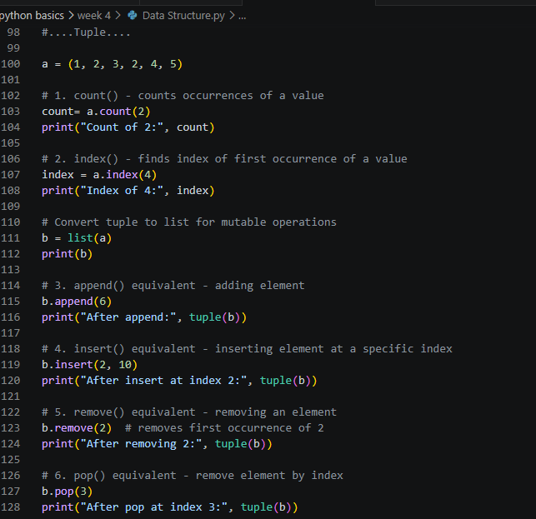
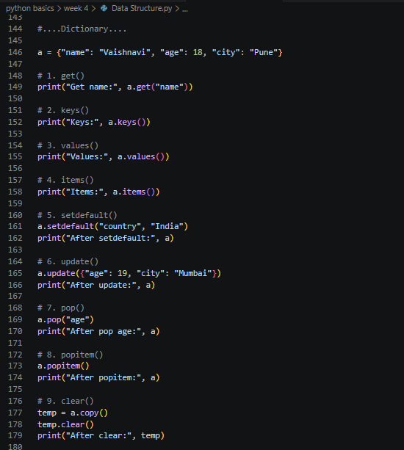

3.7 Exception Handling and Error
Exception Handling is a mechanism in Python used to handle runtime errors in a program. Instead of stopping the execution when an error occurs, exception handling allows the program to continue running smoothly by managing the error.
Errors that occur during program execution are called exceptions. Handling these exceptions properly improves program reliability and prevents crashes.
